
Bus Tracking and Arrival Time Prediction System Using Driver's Phone GPS


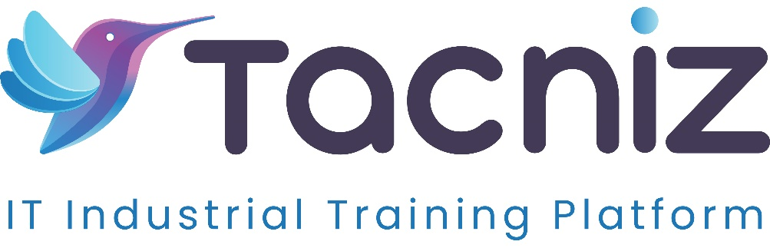
- Problem Statement:
Passengers often struggle with unpredictable bus arrival times, especially during delays caused by traffic or other interruptions. To improve the passenger experience and reduce uncertainty, this project aims to develop a real-time bus tracking and arrival time prediction system using the bus driver's phone GPS. The system will provide accurate, real-time updates on bus locations and expected arrival times, allowing passengers and bus station operators to monitor bus schedules and delays.
- Type:
Web and Mobile-Based Application
- Industry Area:
Transportation, Public Transit
- Software Expertise:
- Frontend:
  - Web: HTML, CSS, JavaScript for building the user interface.
  - Mobile: React Native or Flutter for developing Android and iOS apps, providing real-time bus tracking features.
- Backend:
  - Python (Flask/Django) or Node.js for creating APIs to handle bus location updates and data storage.
- Database:
  - MySQL or PostgreSQL for managing bus schedules, GPS data, and other related information.
- APIs:
  - GPS tracking APIs to fetch the real-time location of buses from drivers’ phones.
  - Google Maps API for mapping the bus routes and displaying bus locations and estimated arrival times.
- Use Cases:
- Passengers:
  - Check real-time bus arrival and departure times.
  - Receive notifications on delays or changes in bus schedules.
  - Track the real-time location of buses approaching their stop via web or mobile app.
- Bus Station Operators:
  - Monitor real-time bus departure times and any delays.
  - Display live bus arrival information on digital boards at stations.
- Admins:
  - Manage and update bus routes and schedules.
  - Monitor the entire bus fleet and track real-time GPS locations for all buses.
  - Analyze historical data for route optimization and identifying bottlenecks.
- Outcomes:
- For Passengers:
  - Convenience and peace of mind with accurate, real-time bus tracking and arrival predictions.
  - Reduced waiting times and fewer missed buses due to delays.
- For Bus Operators:
  - Better schedule management and coordination, increasing efficiency and transparency in public transportation services.
  - Enhanced communication with passengers through real-time updates on delays and changes in bus schedules.
- For Society:
  - A more efficient public transportation system leading to reduced crowding at bus stops and better traffic management.
  - Encouragement of public transport usage through improved reliability and ease of access.
- Benefits:
- Real-time tracking improves passenger experience by reducing the frustration of unpredictability.
- Provides useful data for bus operators and city authorities to manage transit systems more effectively.
- Potential to optimize bus routes and schedules, improving overall efficiency.
- Duration:
5-6 months.

